Date | Parish | City/Link Charities
1st | Pray for the Senior Leadership Team meeting today. Also for the plans for Kings Barton.  Harestock Assembly – please pray for Ellie advertising our Easter events and services.  For the Buildings Committee meeting tonight.  Those who live in Westley Close | Winchester City Council leader – Caroline Horrill  Pray for those combating human trafficking in the UK,- cases found in Edinburgh, Cardiff, London, Bristol , Somerset and Wiltshire
2nd | Pray for God to speak to us as we meet as a church to pray this afternoon and evening.  Those who live in Loyd Lindsay Square | Kings Barton – for those still building houses and working on the roads.
3rd | For those attending Beehive to feel at home and amongst friends.  For the Beehive Alpha.  Those who live in Malmesbury Gardens | Refugee camps in Uganda  – lack of food, lack of education for the children, shortage of building materials.  -Psychological sickness - missing members of families.  - Boredom – particulary for youth
4th | Tiddlywinks – For God to bless all who attend!  For those suffering from Arthritis and Rheumatism and other joint affecting illnesses.  Those who use Dean Park | Please pray for the Samaritans Projects (wells, sewing centres and MEDs in northern India) who are looking at ways to obtain more sponsors for their work. It is a key part of the evangelistic outreach by the (often persecuted) Indian churches with whom Steve S works.
5th | Please pray for the youth providing car washing for charity tomorrow. For cars to wash, sunshine and blessings!  Pray for those living in Godwin Close | Please pray for those planning events for Pentecost. For God to guide and provide!
Sat 6th | Please pray for the preacher, worship leaders, intercessors’ and children’s workers. (especially the Streams Team)  Messy Church –that the community will grow in relationship with God and each other.
Sun 7th
8th | School Holidays – for teachers, children, parents for a restful break.  For those living in Burnett Close | MP – Steve Brine, - for guidance, wisdom and strength.  Please pray for the countries who are a source of human trafficking: Vietnam, Mongolia, Ghana, China, Nigeria, Pakistan (further list available on request)
9th | For all those who do not yet know the Easter story.  For those who live in Ruffield Close | For the City Council. – Look up your local councilor and pray for them.  For the victims of human trafficking. For emotional and physical healing.
10th | For Ed as he speaks at Beehive Alpha. For a fresh outpouring of Gods Holy Spirit on all who attend.  For those who live in Orchard Walk | Kings Barton – for those who have already moved in. For a Godly community to grow there.
11th | Easter Crafternoon – For the plans and preparations to bless local families.  For those living in Fromond Road | Yei – please continue to pray for all those at St Phillips, those working and attending the clinic. For peace and safety.
12th | For the youth and team who run the Base. For more volunteers.  For those who work and study at Harestock Primary School. | For the Kings Barton event tomorrow afternoon. For it to be a lovely happy community event. For “Godly” conversations.
Sat 13th | Please pray for the preacher, worship leaders, intercessors’ and children’s workers (especially the Rivers team)  Please pray for those around the world who are caught up in conflict and danger.
Sun14th
Palm Sunday
15th | For Ed as he does the Easter Talk at the Lunch Club. For all those attending to be blessed.  Those who live in Fleming Road | For all our brothers and sisters around the world who are preparing for Easter and remembering the incredible story.
16th | Please thank God for your Study group leaders. Ask God to guide them and build them up in wisdom and care for the groups they lead.  Those who live in Bradley Road | For all those around the world who are unable to celebrate Easter due to persecution. For God to bless them and set them free.
17th | Thank God for the things He has taught us in Lent for when we have stepped out in faith; that the things we have tried to implement in our lives do not stop and that we continue to grow as individuals and as a body.  For Beehive members to enjoy and be blessed by Eds Easter talk.  Those living in Ashley Close | For all those leading services over the Easter period. For us to hear God speak through them.
18th  ^{Maundy Thursday} | For those attending the Maundy Thursday Service tonight.  For those suffereing from Asthma and Emphysema, and other illnesses affecting breathing.  Those living in Bramshaw Close | Basics Bank – thank God for this provision. Pray for the families who need to use it.
19th  ^{Good Friday} | Easter Crafternoon – blessings on families and communities – that they will learn something of who God is and how he loves them.  For someone you know who hasn’t yet accepted Jesus as their friend and saviour. | Pray for those who struggle to understand the Easter message and all that Jesus did for us. Ask God to open peoples hearts to his love.
Sat 20th | Spend time praising God for all that he has done for you, for us, for everyone who will accept his gift. Remember his names, his promises and his faithfulness. Write a poem, sing a song, paint a picture, have a party, celebrate! You are free and beloved!
Sun 21st
^{Easter Sunday}
22nd | For Steve as he oversees the House Groups, and Ed as he plans and prepares the Prayer Course.  Those living in Winslade Road | County Council – for the planning and decision making.  Pray for the perpetrators of human trafficking.
23rd  St Georges Day | For Churches Together in Winchester to bless each other and flourish.  For Christian teachers and students in Henry Beaufort School be drawn together to support themselves and reach out to others.  Those living in Burley Road | Kings Barton – for all those contemplating buying houses. For God to direct people to Winchester to create a Christian community there.
24th | For Beehive, - those unable to attend due to infirmity or other issues. For them not to feel isolated.  For Ed as he oversees the Ordinands and members of staff.  Those living in Swanmore Close | South Sudan. Please continue to pray for peace for the whole country. For reconciliation. For the up-coming generations to choose NOT to fight.
25th | For Tiddlywinks – the planning and running of the sessions. For enough volunteers.  For those suffering from Eczema and skin conditions/cancer.  Those living in Litchfield Road and Minstead Close. | For all students facing the stress of exams.
26th | For guidance as the team starts to think and plan the childrens and family activities over the summer.  For the Base meeting tonight.  Those who live in Hambledon Close | For Trinity and Night Shelter
Sat 27th | Street Pastors Annual General Meeting. Generally for the Street Pastors.  For St Lukes APCM.  Please pray for the preacher, worship leaders, intercessors’ and children’s workers (especially the Rapids team).
Sun 28th

St Barnabas Church
April Prayer Diary

Please continue to pray for our Nation everyday as well! God is at work and we can trust him, but we do need to keep talking to him about it all!

1 Timothy 2:1-3: I urge, then, first of all, that petitions, prayers, intercession and thanksgiving be made for all people— for kings and all those in authority, that we may live peaceful and quiet lives in all godliness and holiness. This is good, and pleases God our Savior, who wants all people to be saved and to come to a knowledge of the truth

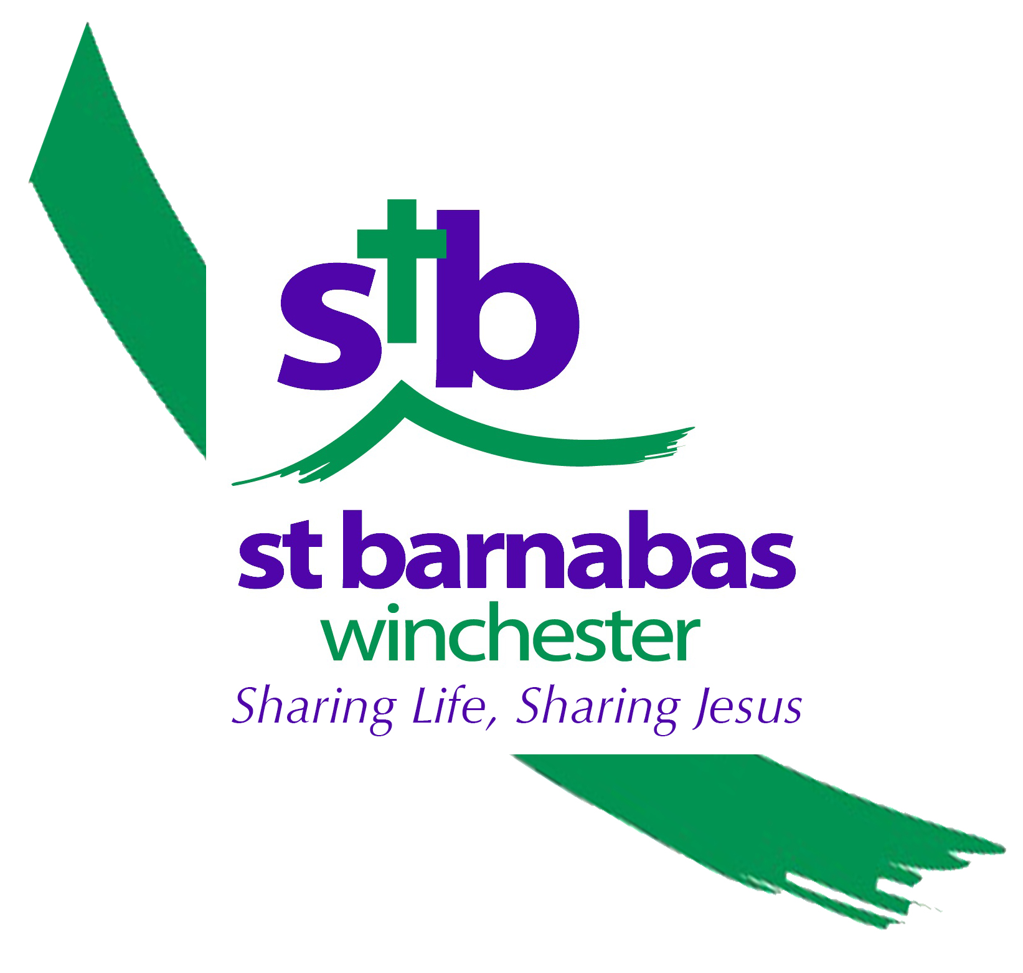
Please send prayer ideas to Lucy, Ed or Helen in the office.

