[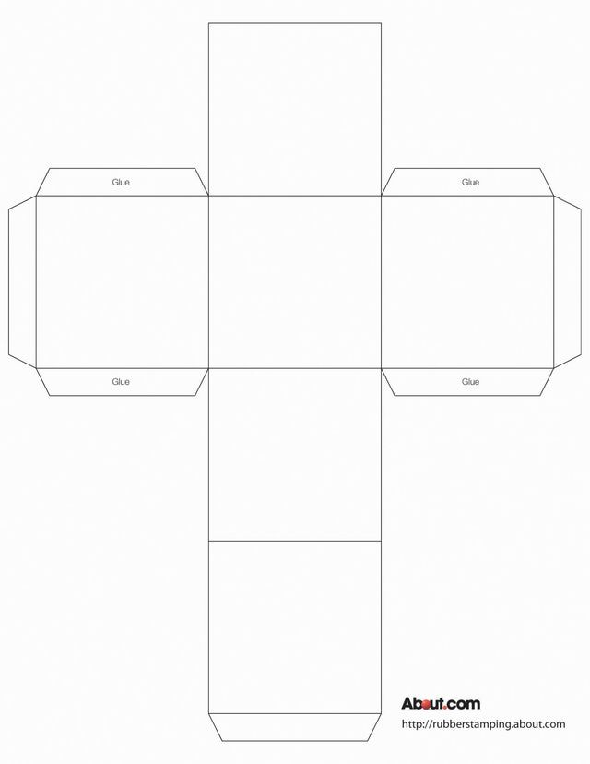](https://www.google.co.uk/url?sa=i&url=https://www.pinterest.com/pin/24840235419789535/&psig=AOvVaw0tbzYNQSsu43KyjI8ltTuD&ust=1586611703609000&source=images&cd=vfe&ved=0CAIQjRxqFwoTCNDFy6v73egCFQAAAAAdAAAAABAD)