3. Jesus praying in the garden
Jesus goes to a garden in Gethsemane with his friends to pray. His friends were too tired and fell asleep! But Jesus was troubled, he knew he was about to face a difficult time ahead and he spent the night praying to God his father for help. Knowing what was about to happen to him he prayed, ‘not what I want, but what you want God’. Just like Jesus, we can pray to our father in Heaven too.

- Create a hand print prayer. Use it to pray for the world, for others, your friends and family and also for yourself.

Prayer:
“Jesus, teach me how to pray like you. Thank you that you hear my prayers. Amen”

Step 1
Take a piece of paper and either draw round your hand, or make a painty hand print. Cut out your hand print and stick onto a another piece of card or paper.

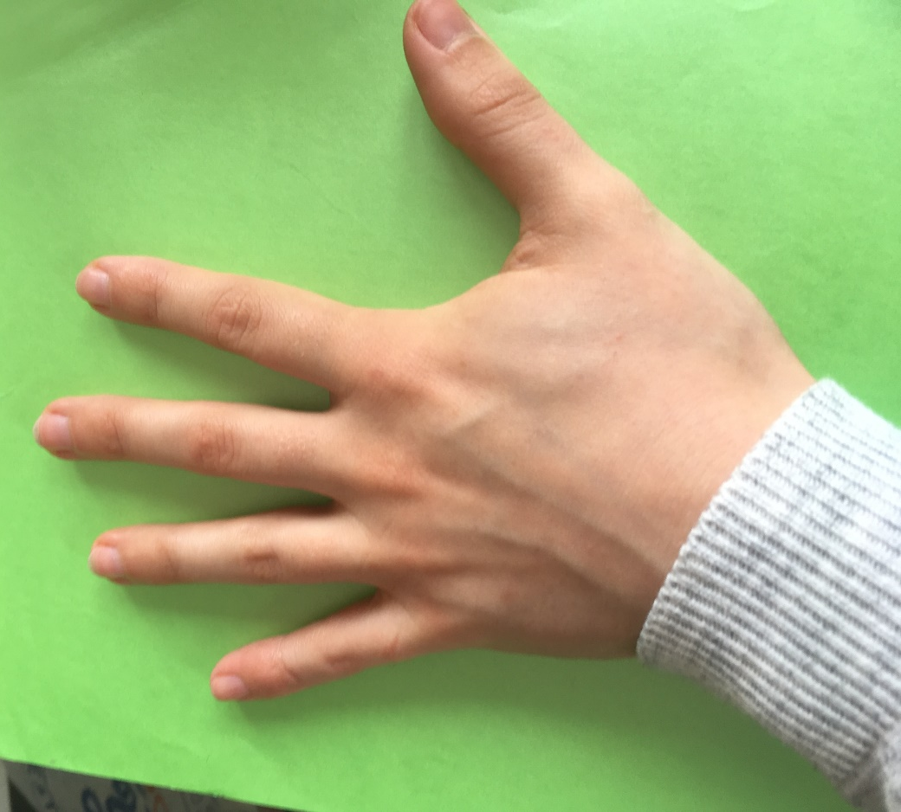
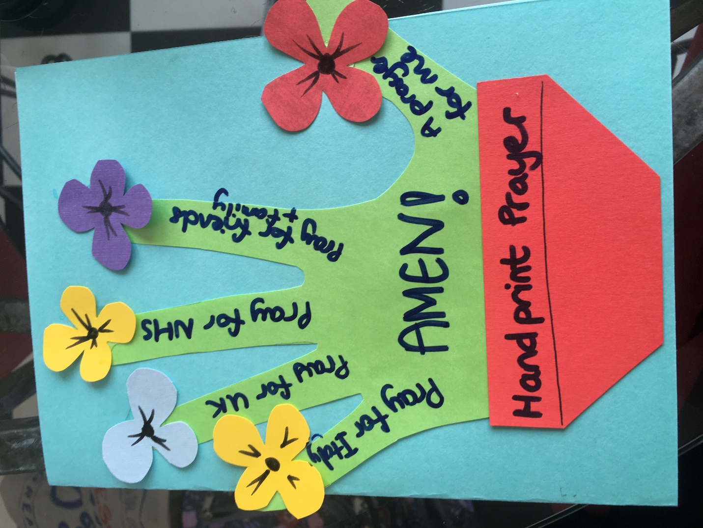
Step 2
Cut out or draw on a flower at the tip of each of your fingers, and add a flower pot at the base of your palm – as shown.
Then add your prayers. Starting with your little finger and ending with your thumb!
Little finger: Pray for another country as they battle against the virus
4th finger: Pray for the UK and all its citizens
Middle finger: Pray for the NHS, key workers and those who are poorly right now
Index finger: Pray for your family and friends, for their safety and knowledge of God’s presence
Thumb: Pray for yourself. What would you like to ask God for right now?
And write a big AMEN on the palm – a way of saying, let it happen!

