5. The tomb is empty!
They took Jesus’ body off the cross and placed him in a tomb. But 3 days later some of Jesus’ friends found the tomb open and empty. Jesus had come back to life! He appeared to his friends several times and encouraged them before going to Heaven.
By coming back to life, Jesus made a way for all of us to have new life when we trust in him…a fresh start with no strings attached. We are saved by his gift of grace alone and not our own works. Yippee!

- Make your own Easter garden. Be inventive and use things either from your garden or your recycling bin!

Prayer:
“Jesus, thank you that you are alive and that we can have a new life in you. Please can I have a fresh start? I choose to put my trust in you. Amen”

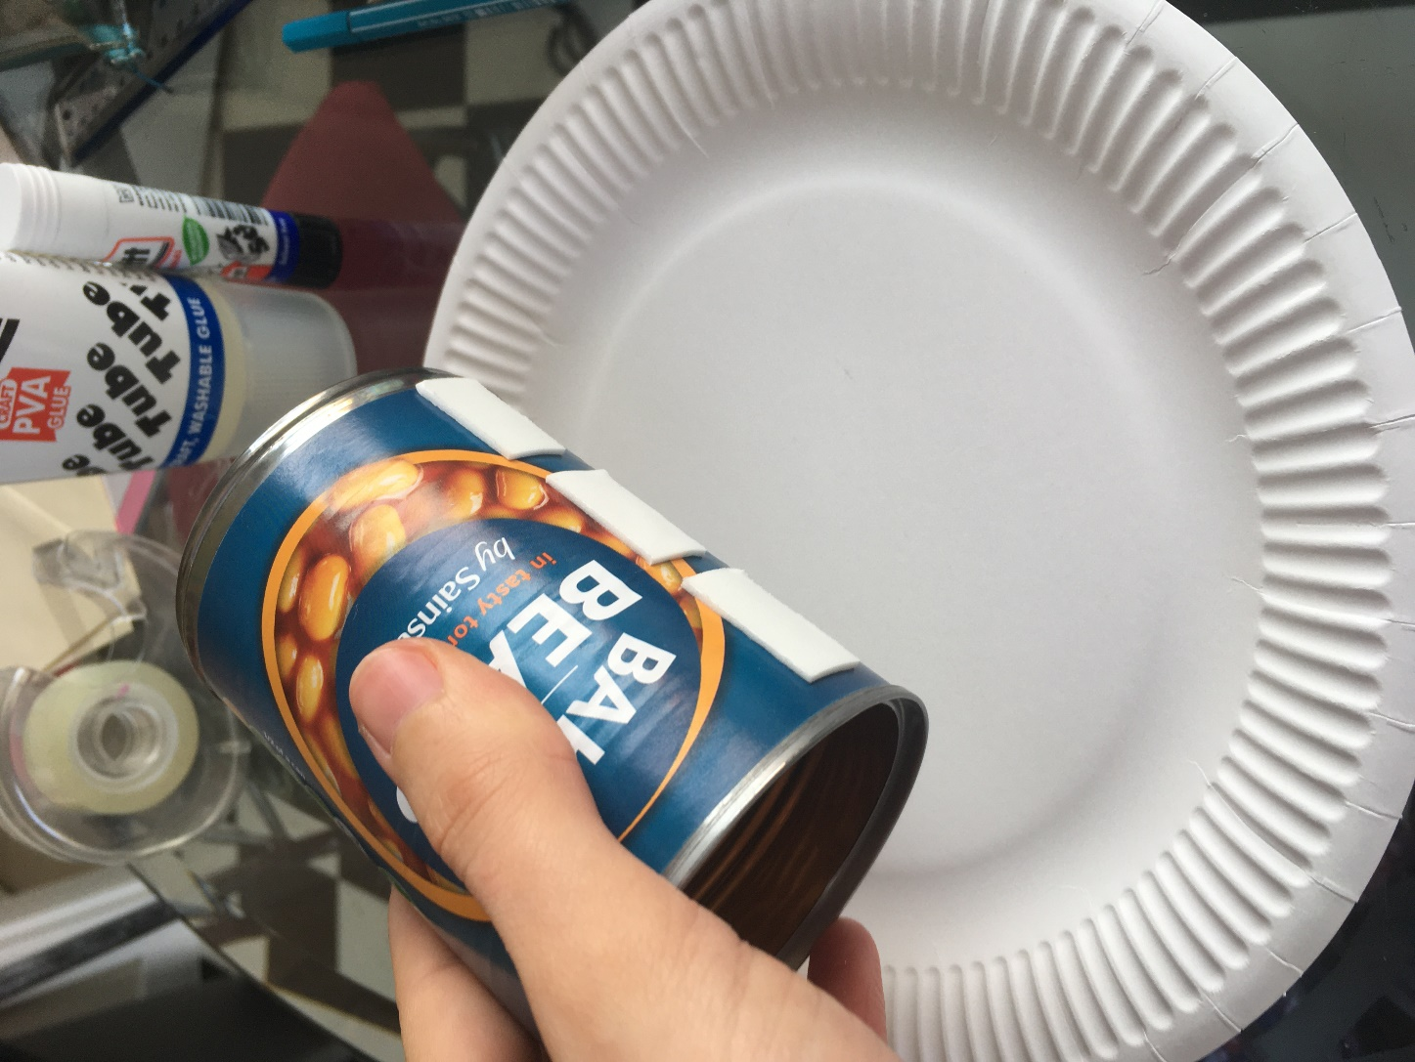
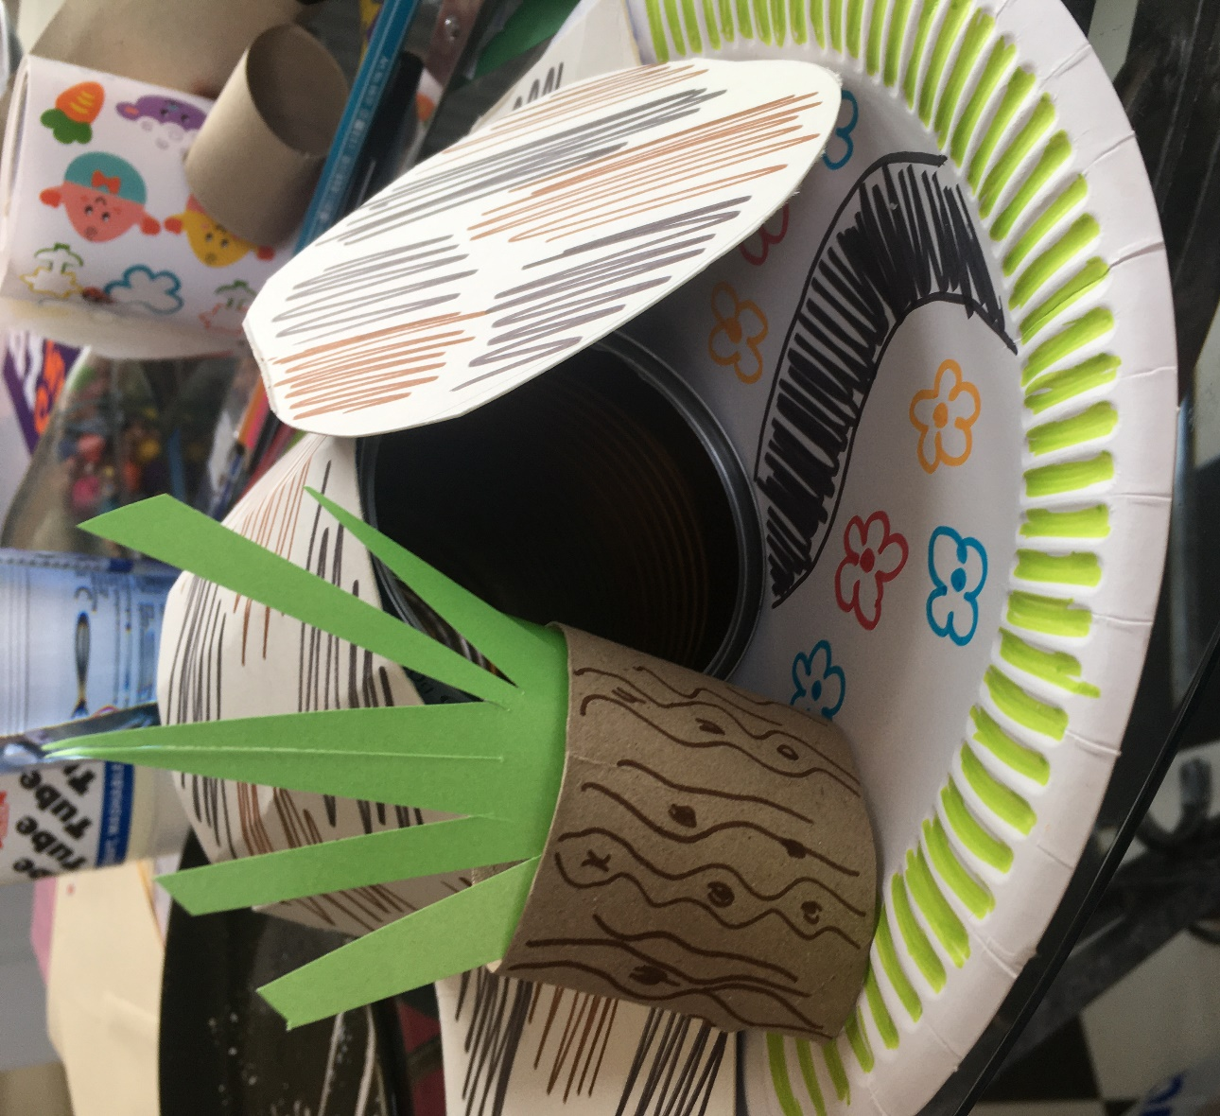
Step 1
You can be as inventive as your like with your Easter garden. Below is an example of how I made mine, but you could explore the garden and use stones and twigs and grass for yours. An Easter garden usually includes: a cross, a tomb with the stone rolled away, some trees, maybe even some figures for the angel, Jesus, Mary and the disciples.

