2. Last Supper – He loves you!
Jesus and his disciples (close friends) had just arrived in Jerusalem and all sat down for the special festival meal called ‘the last supper’. Before dinner, Jesus called his friends together and one by one he washed their feet as a sign of friendship and as an example to us of how to serve one another. There was no job too small (or smelly!) that Jesus wouldn’t do for his friends. And we’re his friends if we want to be. As friends of Jesus we’re called to love others just like he loves us.
- Make a ‘This is how much God loves me’ box with scriptures inside. Take a card with a scripture on each day to remind you of how much Jesus loves you.

Prayer:
“Jesus, thank you that you love me and I’m your friend. Help my heart to love those around me. Amen”
Step 1
Either print the net cube attached and cut out, or draw your own using a ruler and a piece of card. I made mine 5cm:5cm…remember to draw on some tabs too! Fold along the drawn lines and sellotape in place to make your box.

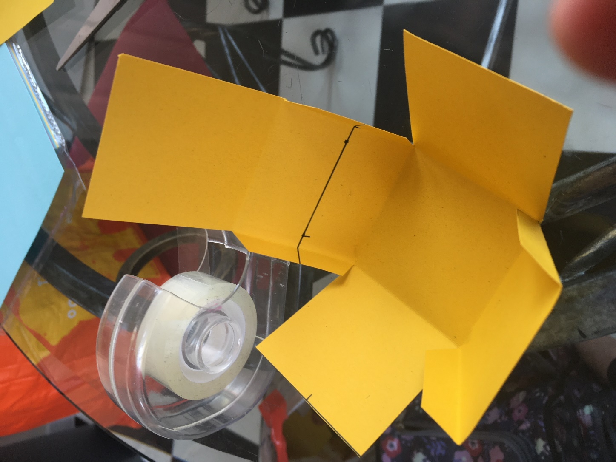
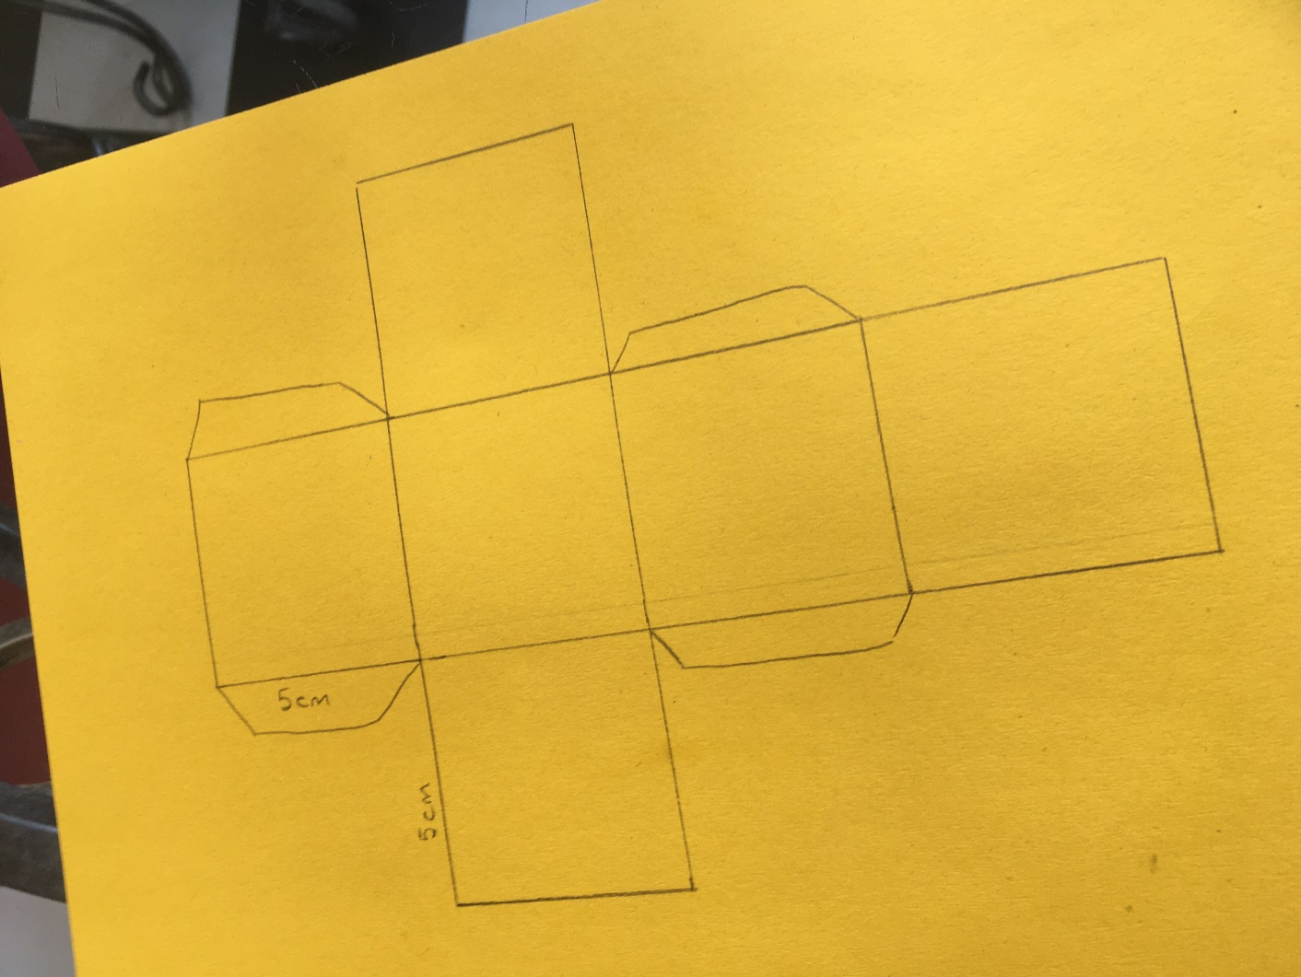

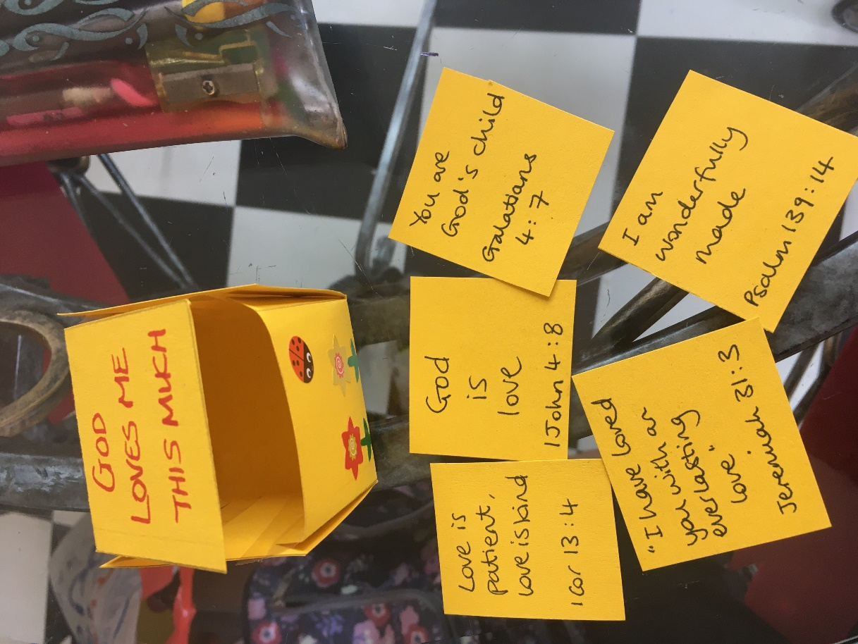
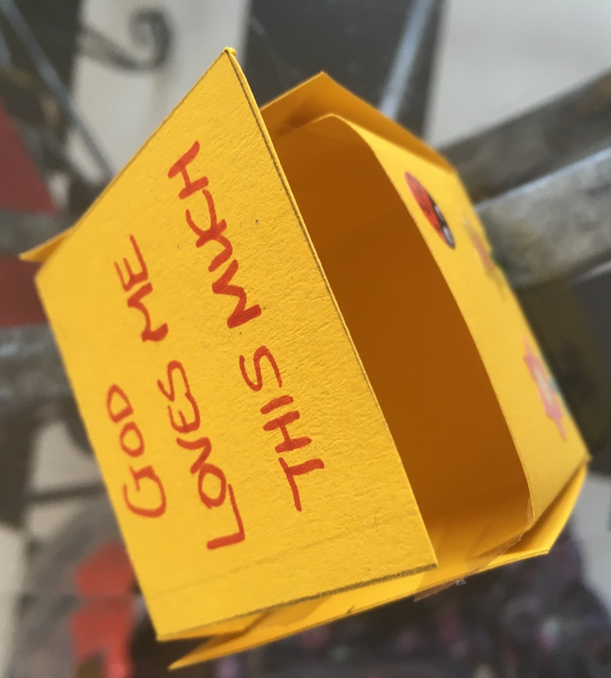
Step 2
Decorate your box, cut out little cards the right size to go inside and write your little messages of God’s love for you on each one. You can use the sheet attached for examples and bible passages to look up.

