6. BBQ on the beach!
Once Jesus came back to life, and before he went back to Heaven, he met with his friends one last time. They were fishing in the sea when they saw Jesus sitting on the shore cooking fish for their breakfast. Jesus knew his friends were scared and sad after all that had happened, so He encouraged them and said, “Go out and train everyone you meet, far and near, in this way of life. Then instruct them in the practice of all I have commanded you. I’ll be with you as you do this, day after day after day, right up till the end of the age.” We have the exciting news that Jesus loves us, saves us and gives us eternal life. Let’s go tell our friends!
- Make your very own fishing game. Have fun playing and praying for your friends, that may might be Jesus’ friend too.
Prayer:
“Jesus, thank you for encouraging us when we need it. You have spoken life to us, help us to tell people about you and the life you bring. Amen”
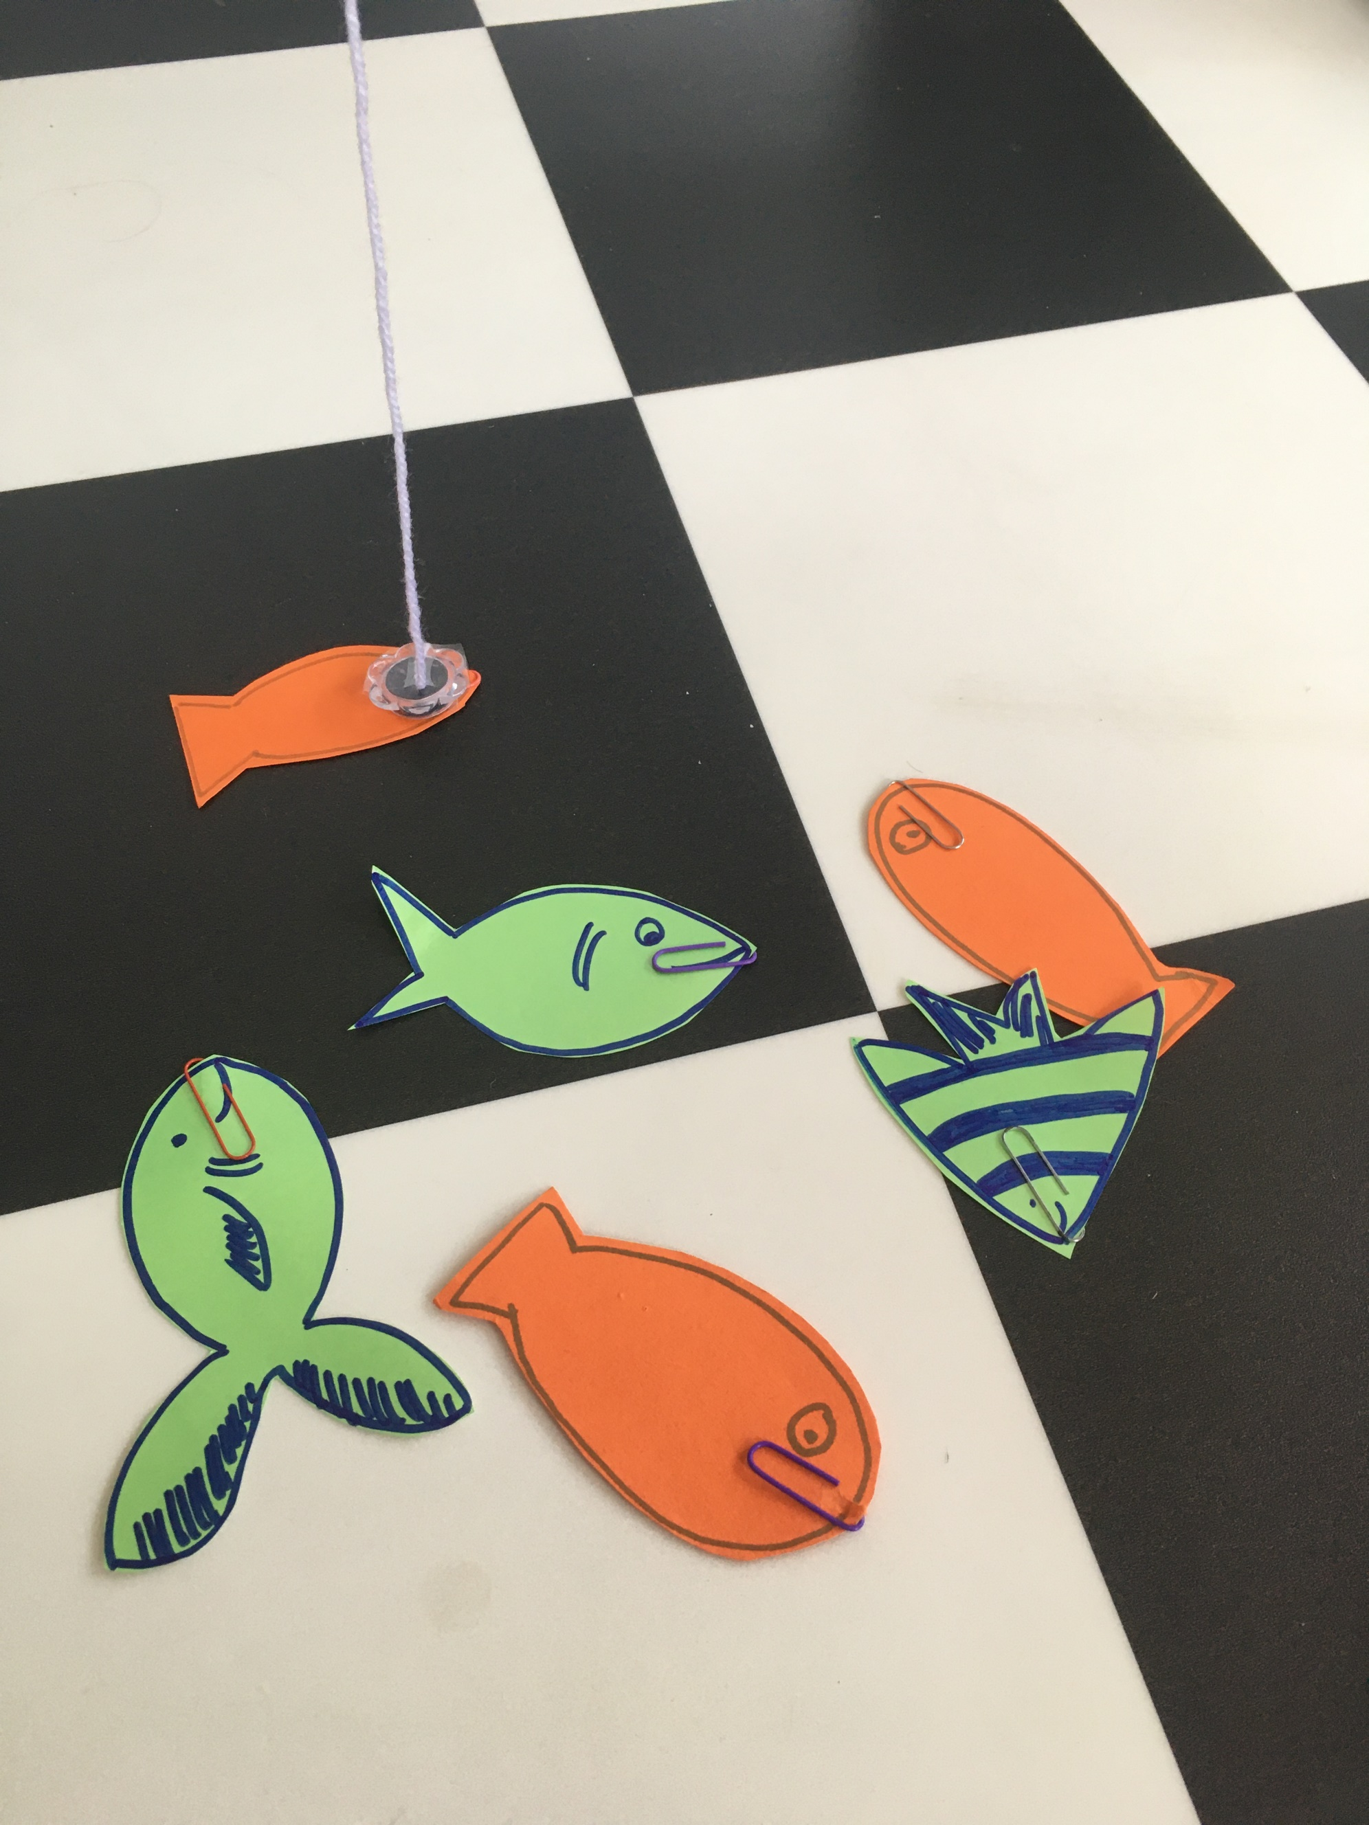
Step 1
Draw and cut out fish shapes from paper. Fasten a paper clip on each fish. Take a magnet off your fridge and Sellotape it to some string or wool. To make the game a little more tricky, add a rod to your string, by either using a kitchen roll tube or a garden cane. Have fun seeing how many fish you can catch! Who in your family can catch the most?!

